Observations of the BLDC motor and sensing circuits

1. This is the PWM input from the Raspberry Pi Pico to control the half bridge drivers at 100 kHz. The code switches between phases at n/6 of the period.

Without turning on the power supply, the following is the PWM signal from the Pi Pico.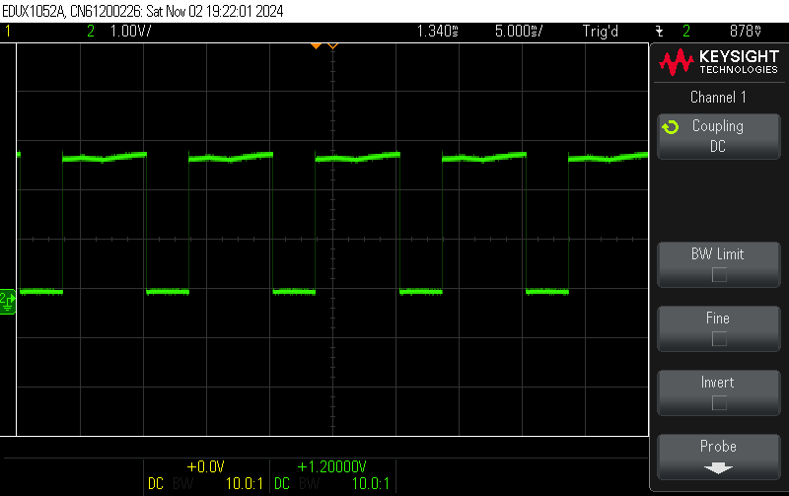

After turning on the power supply, the PWM signal (from Pi Pico) is a lot noisier, possibly due to the interference form the power supply and the high-frequency switching:

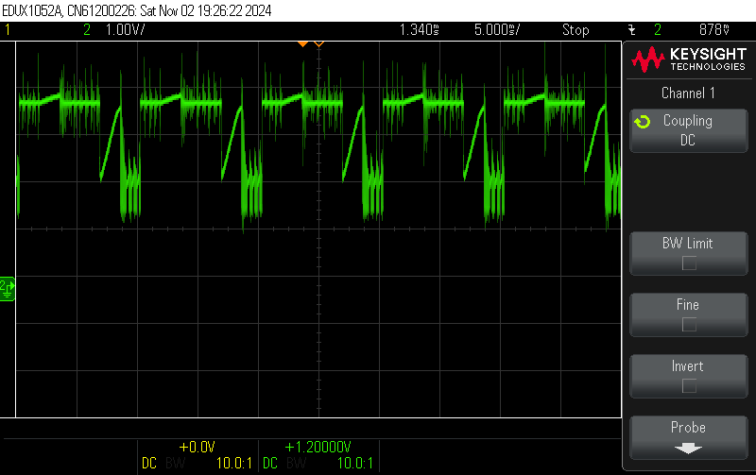

1. Trying to measure the back EMF of BLDC motor through the potential divider

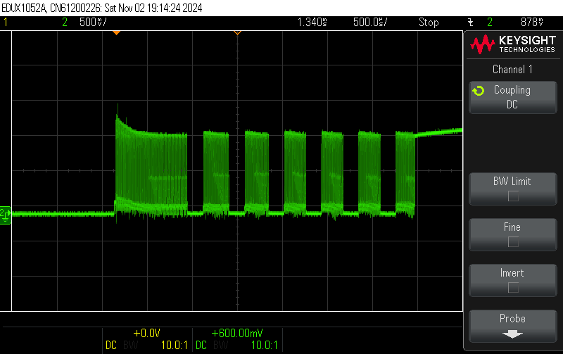

The high-frequency switches within each phase may suggest that there are gate ringing on the MOSFET.

1. Measuring the comparator output

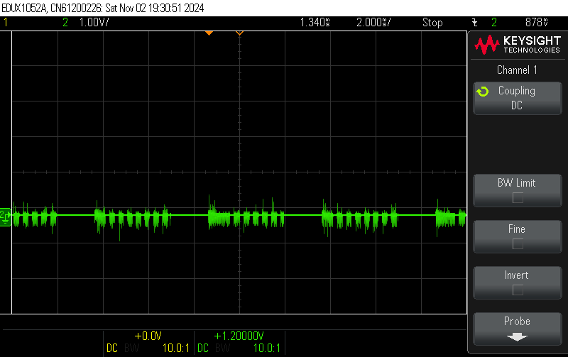

There are a lot of noises from the comparator, but it hasn’t fully turned on.